DAX Basics
- Creating simple DAX Expressions
  - calculated column
The report created in Lab Work 01-03 was opened in Power BI Desktop. The view was switched to Data View by clicking the Data View icon in the left navigation panel. A new Calculated Column was created using the following DAX expression with the FORMAT function:
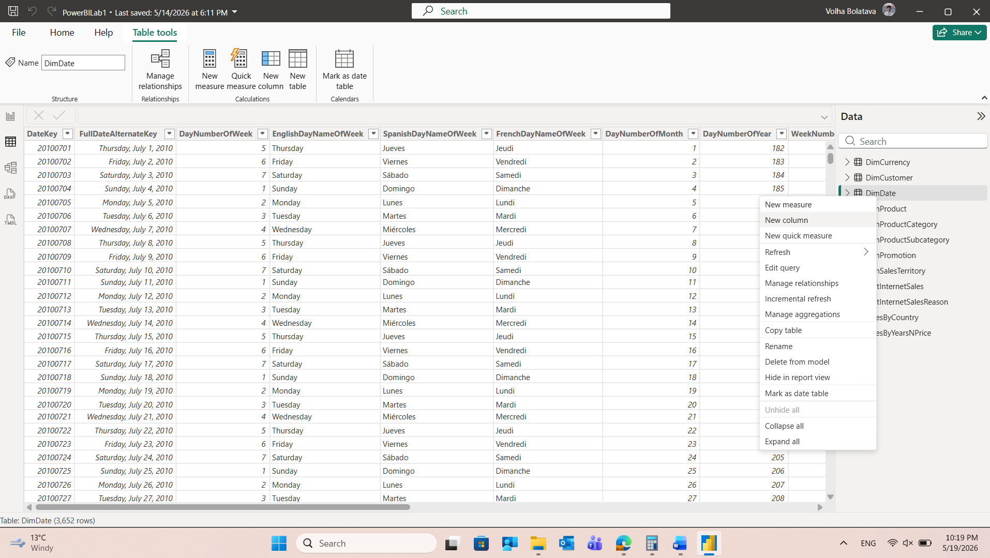 The FORMAT function converts the date value into a text string in the "YYYY-MM" format (e.g., 2013-01), which makes it suitable for use as a chronologically sortable label on chart axes. After pressing Enter, the new column appeared in the DimDate table:
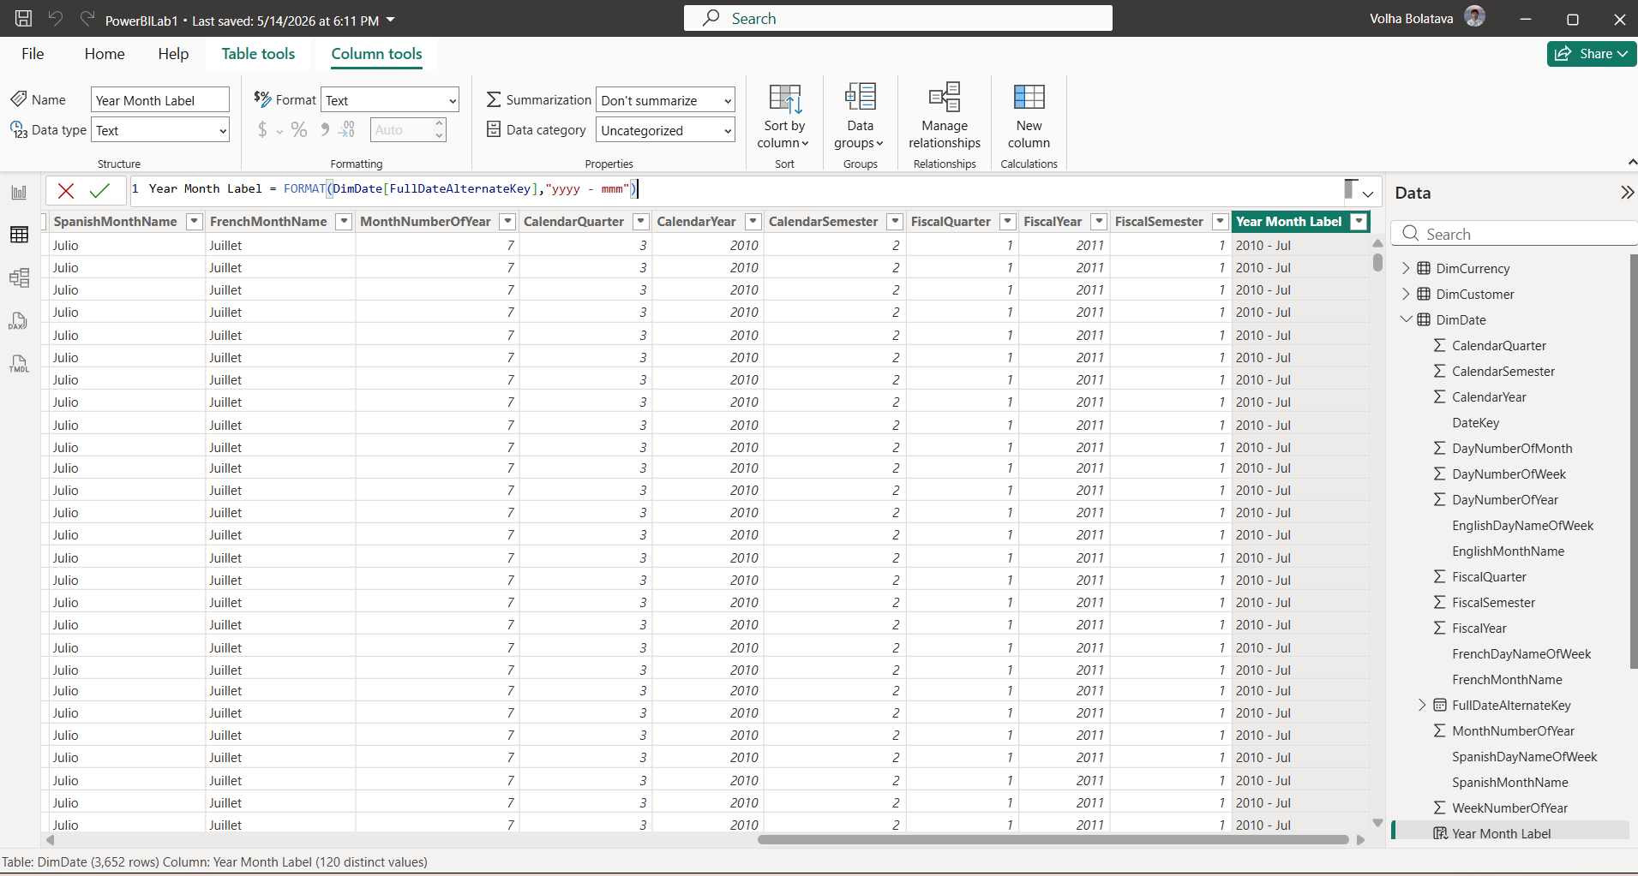
The view was switched back to Report View. A new page was added to the report. A Line Chart visualization was added from the Visualizations pane using OrderDate field and SalesAmount from FactInternetSales table. As a result, the chart displayed the date hierarchy on the X-axis, allowing the user to drill down through different time levels. This approach is suitable when interactive hierarchy navigation is the intended use case.
Also the slicer with OrderDate (YEAR) field was added to the report to enable opportunity to navigate through different periods of time:
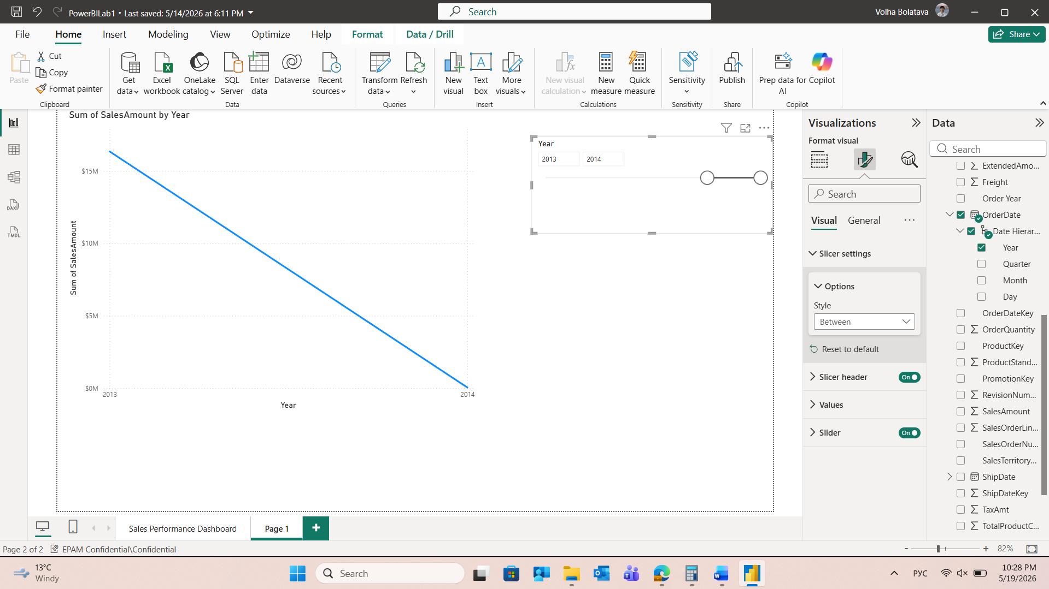
Year Month Label calculated column (created in Step 2) from the DimDate table was used instead of OrderDate. This column was placed in the X-axis field well, and SalesAmount was used in Values. This approach is preferred when a fixed monthly granularity is required, as it avoids the complexity of hierarchy navigation and provides a cleaner, more readable chart for business users:
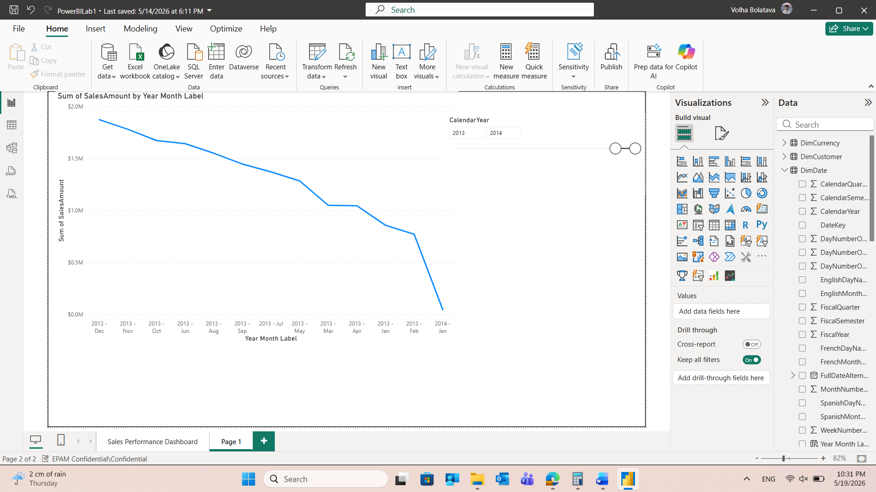
To reduce the number of data points displayed, a filter by calendar year was applied. The filter was configured to show only years from 2013 onwards. This was done by setting the filter type to "is greater than or equal to" and entering the value 2013. As a result, the chart now displays data starting from January 2013, improving readability and focusing on the relevant time period.

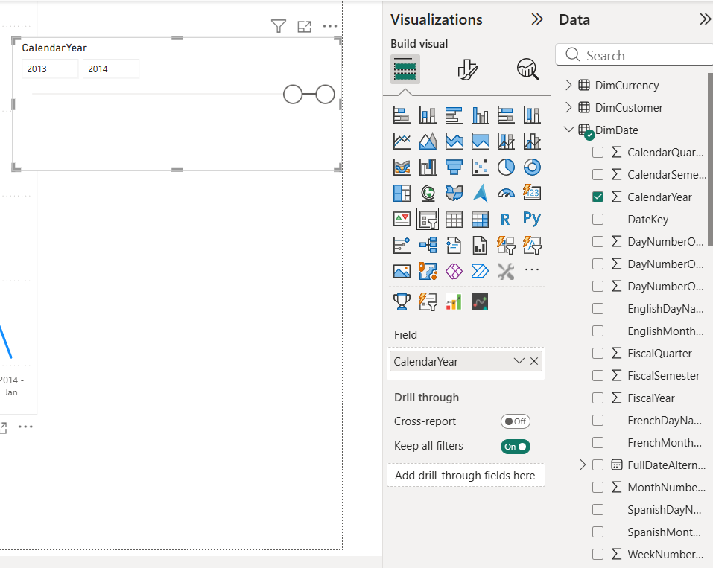
After applying the Year Month Label column to the X-axis, the months were sorted in alphabetical order the following steps were performed to present it in chronological order:
- A new calculated integer column named YearMonthSort was added to the DimDate table using the following DAX expression:
YearMonthSort = DimDate[CalendarYear] * 100 + DimDate[MonthNumberOfYear]
The DAX expression mathematically combines the year and the month number into a single, continuously increasing integer. This calculation ensures that every single month across multiple years receives a unique, absolute numeric key. Since 201401 is mathematically greater than 201307, chart's X-axis displays months in a flawless chronological sequence:

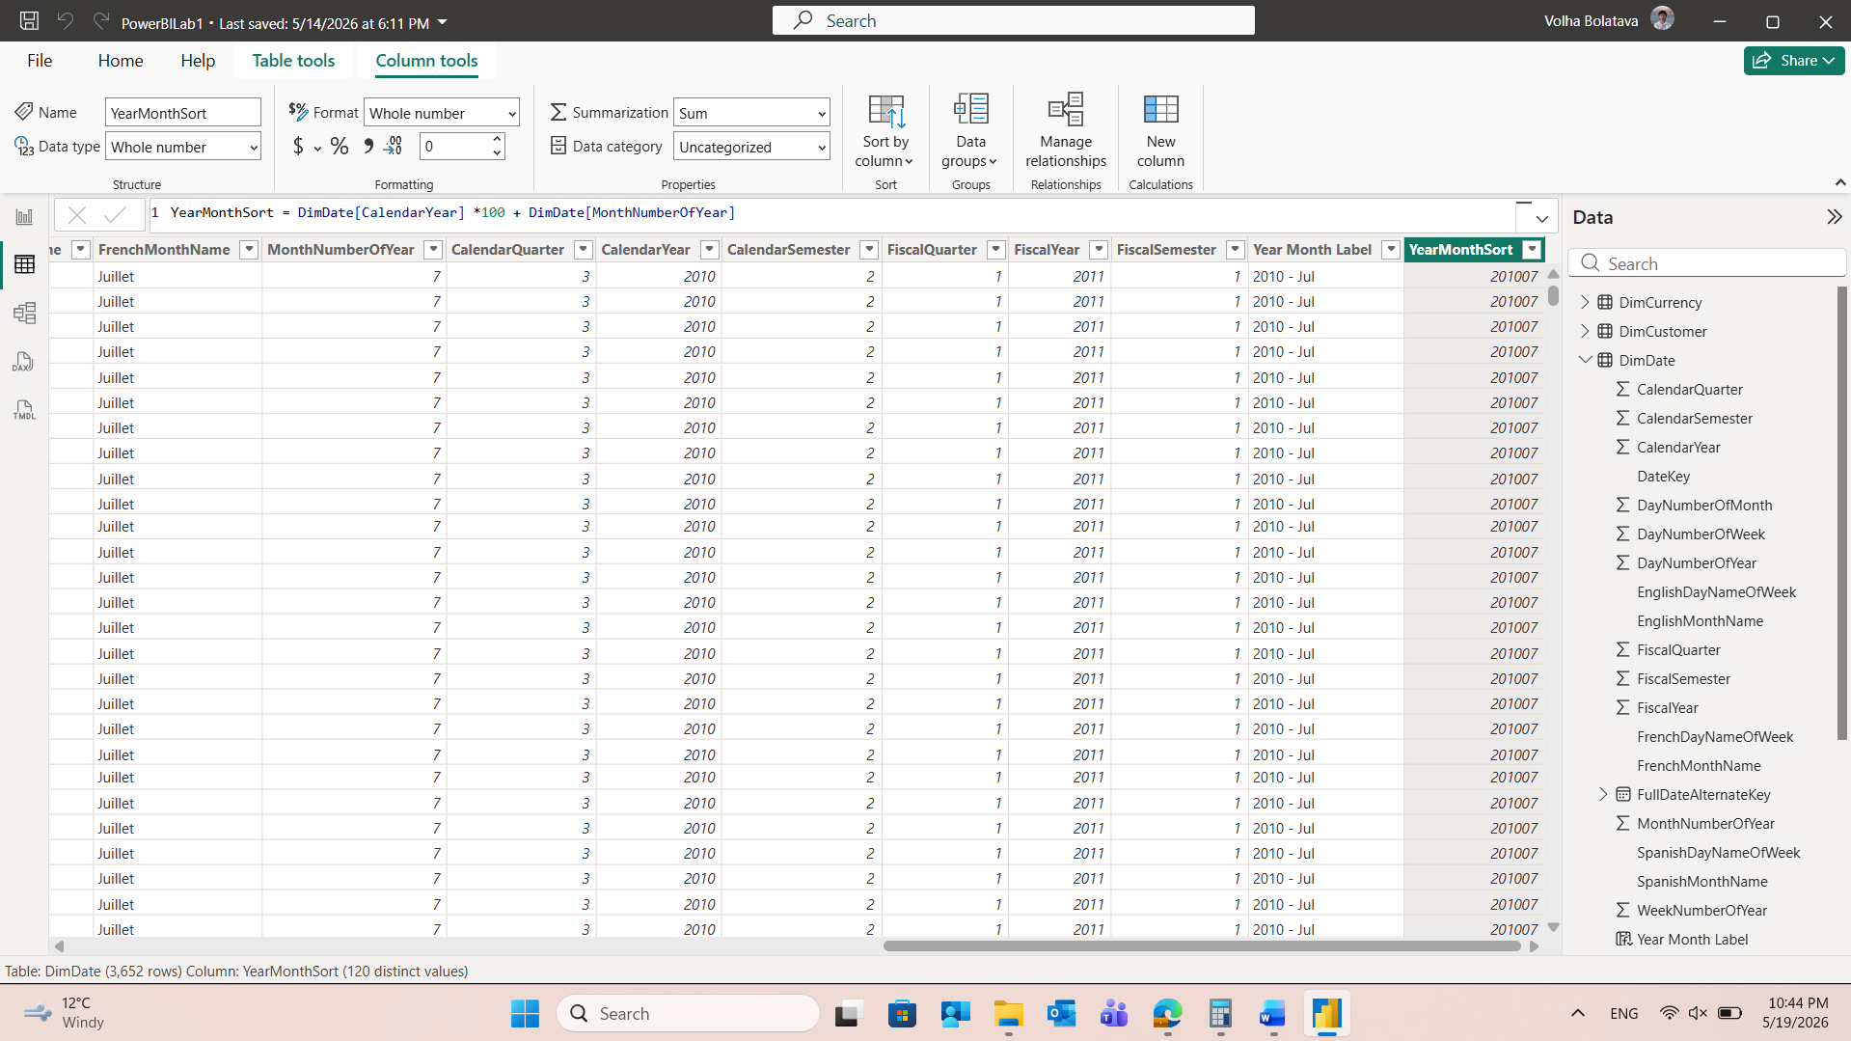
- The Sort by column option was applied to Year Month Label column, selecting the newly created YearMonthSort column as the underlying sorting criteria:
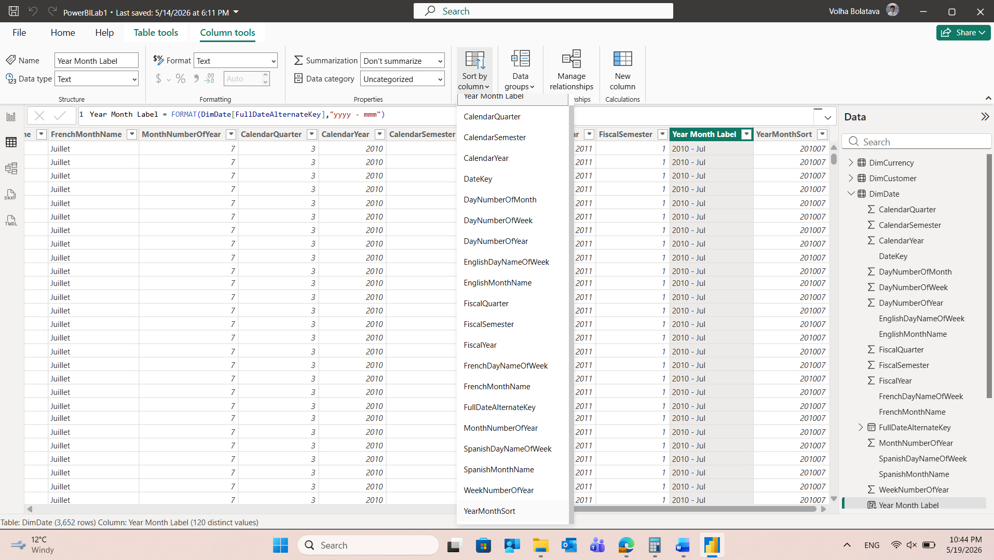
- In the report under Sort axis, the parameter was set to Year Month Label and the sorting direction was switched from Sort descending to Sort ascending:
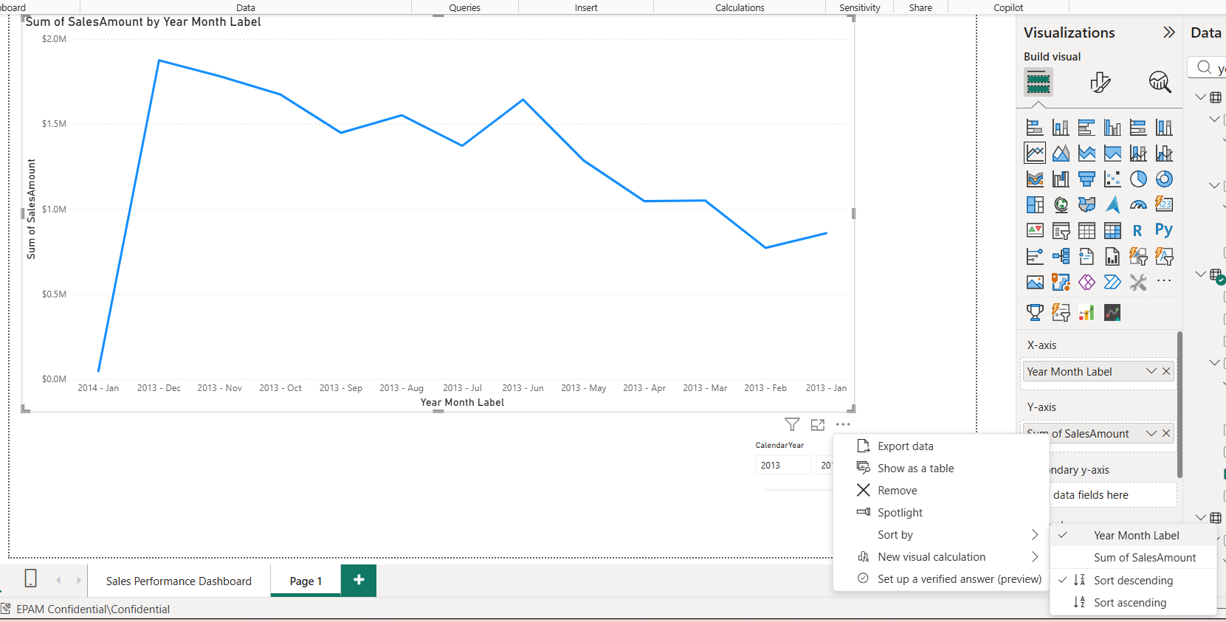
The result:
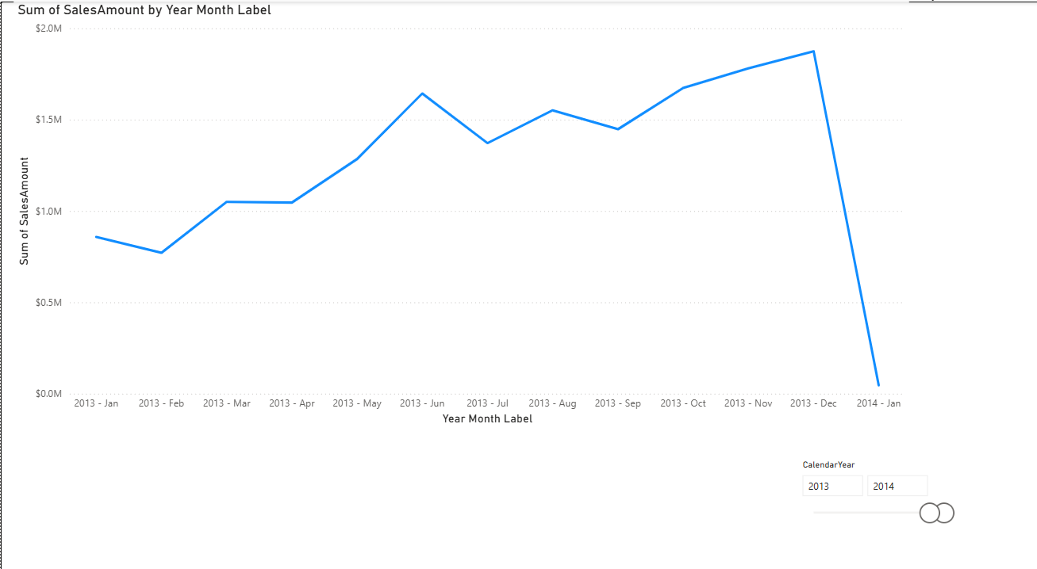

1.2 Measure
The new measure Today Date was created in the table DimDate and displaied in the report using Card visualization:
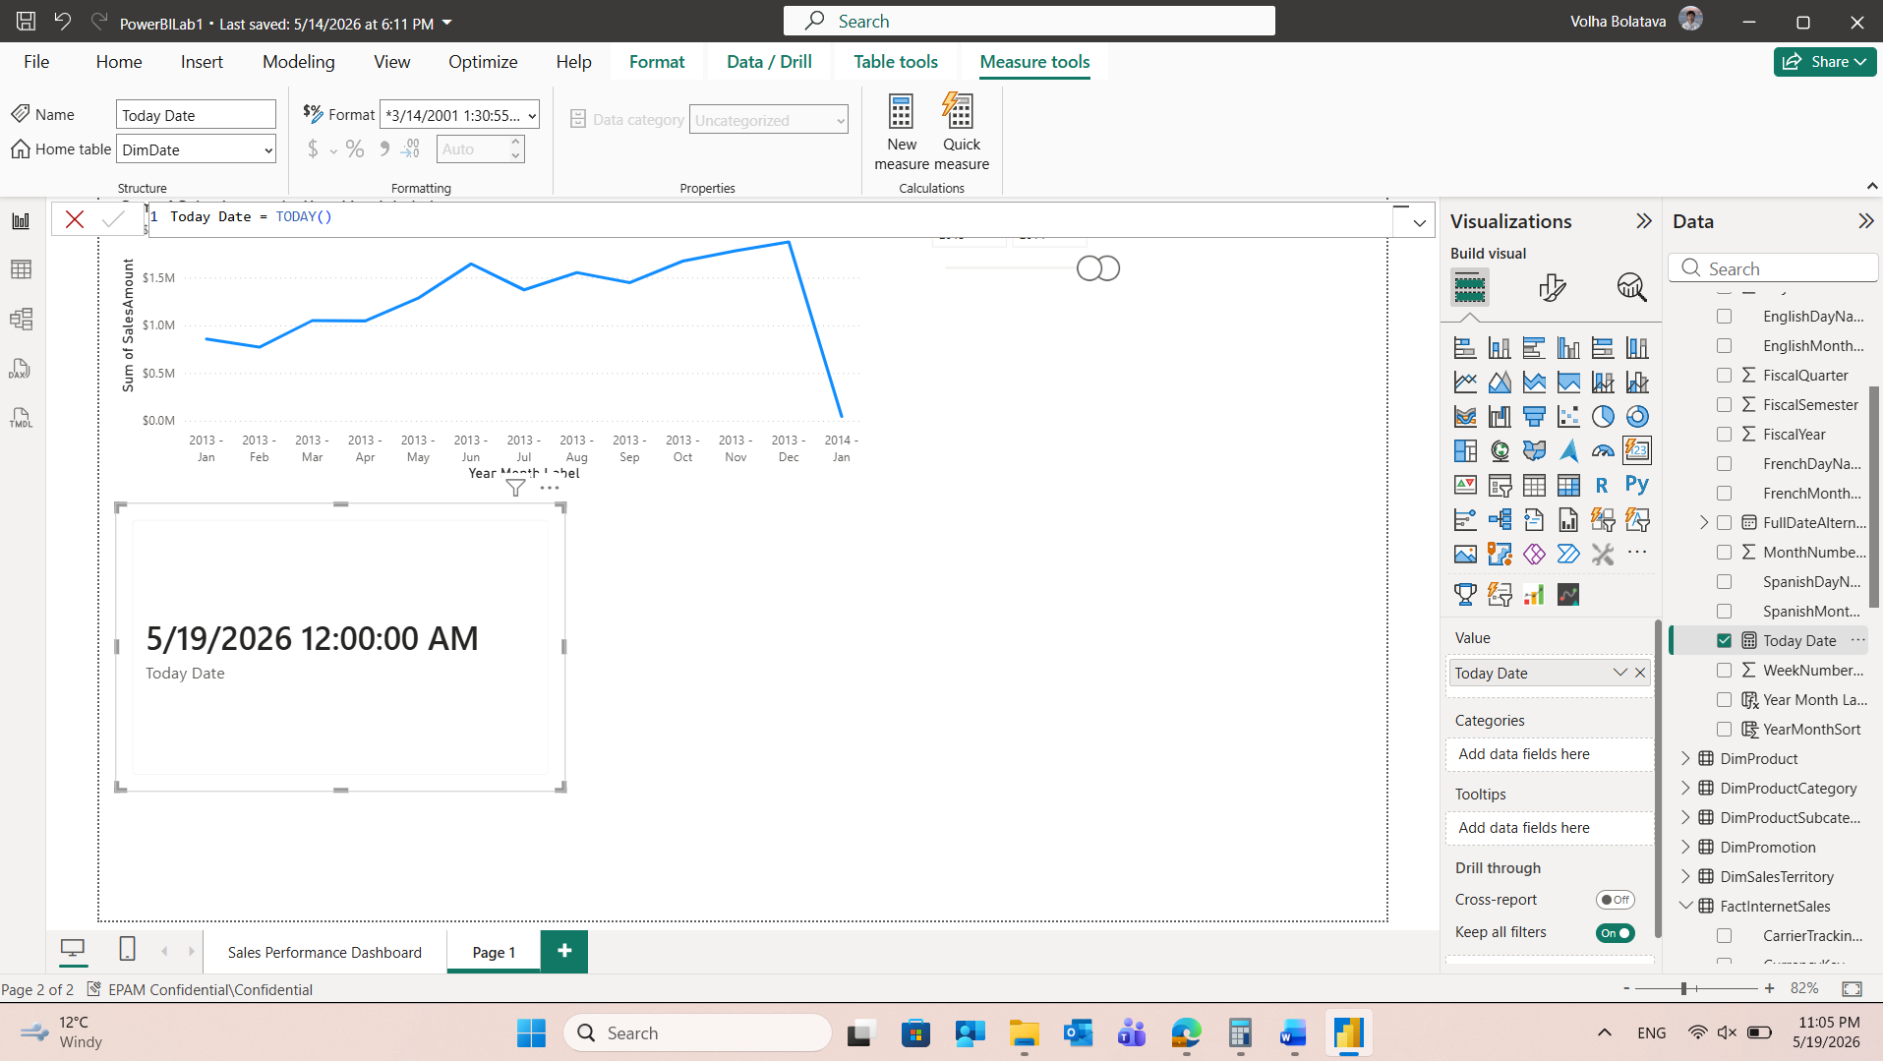
To improve the appearance of the date the Format dropdown was changed from the default long date format to a shorter format, such as Short Date (e.g., MM/DD/YYYY or DD/MM/YYYY depending on locale settings):
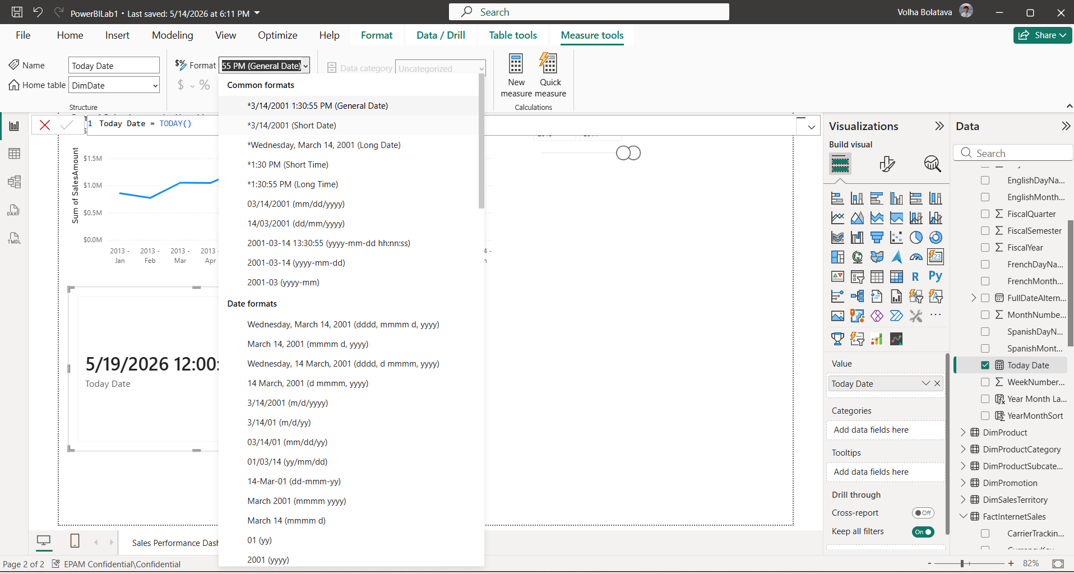
The card on the report canvas immediately updated to reflect the new, more compact date format:
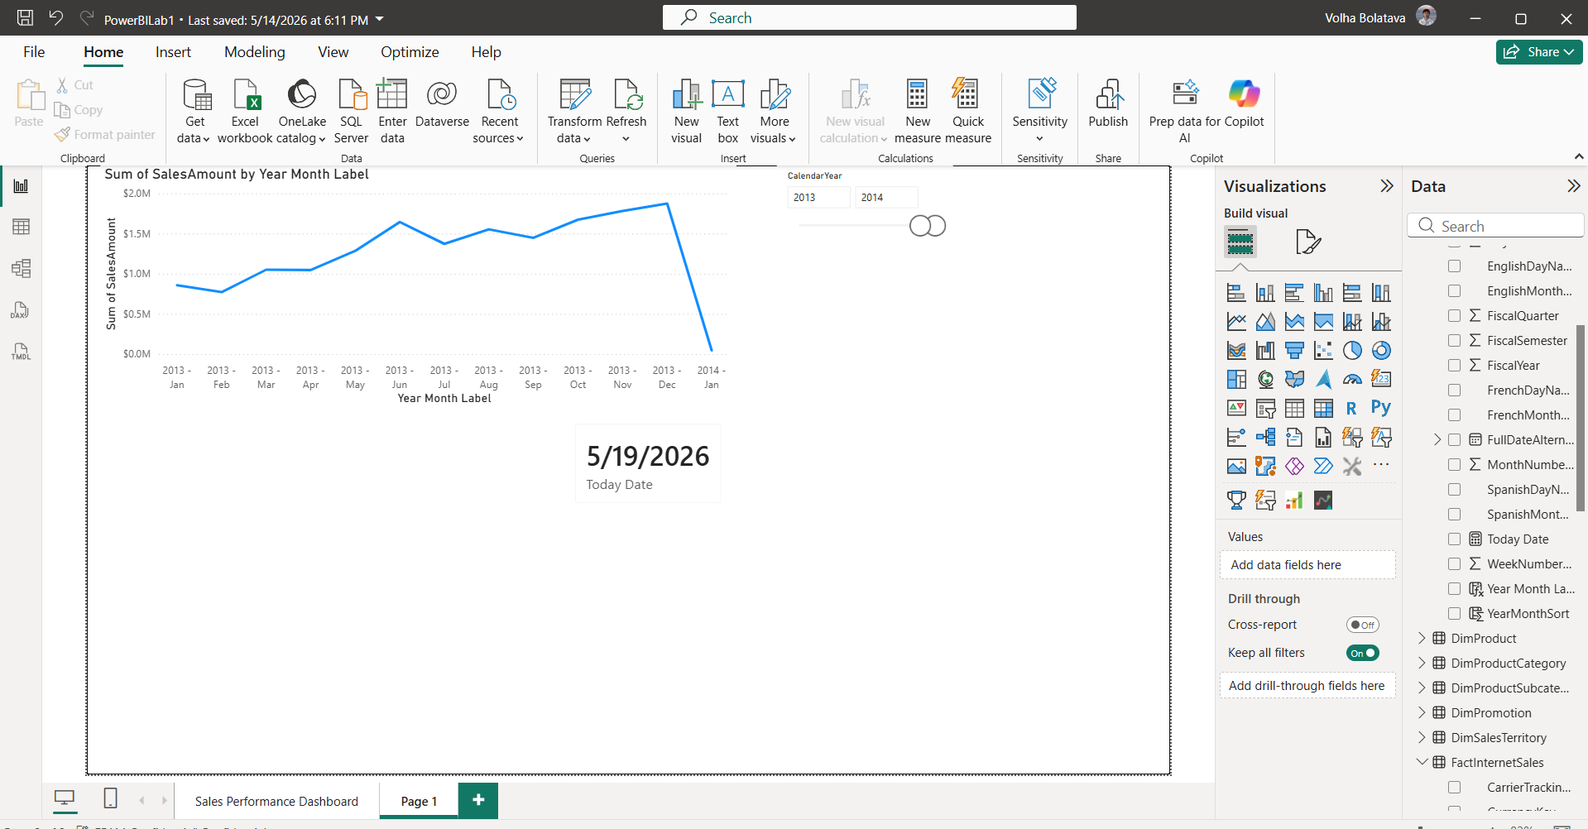
- A new measure Order Quantity was created to calculate the total order quantity. This measure aggregates all values in the OrderQuantity column of the FactInternetSales table, giving the total number of units ordered across all transactions: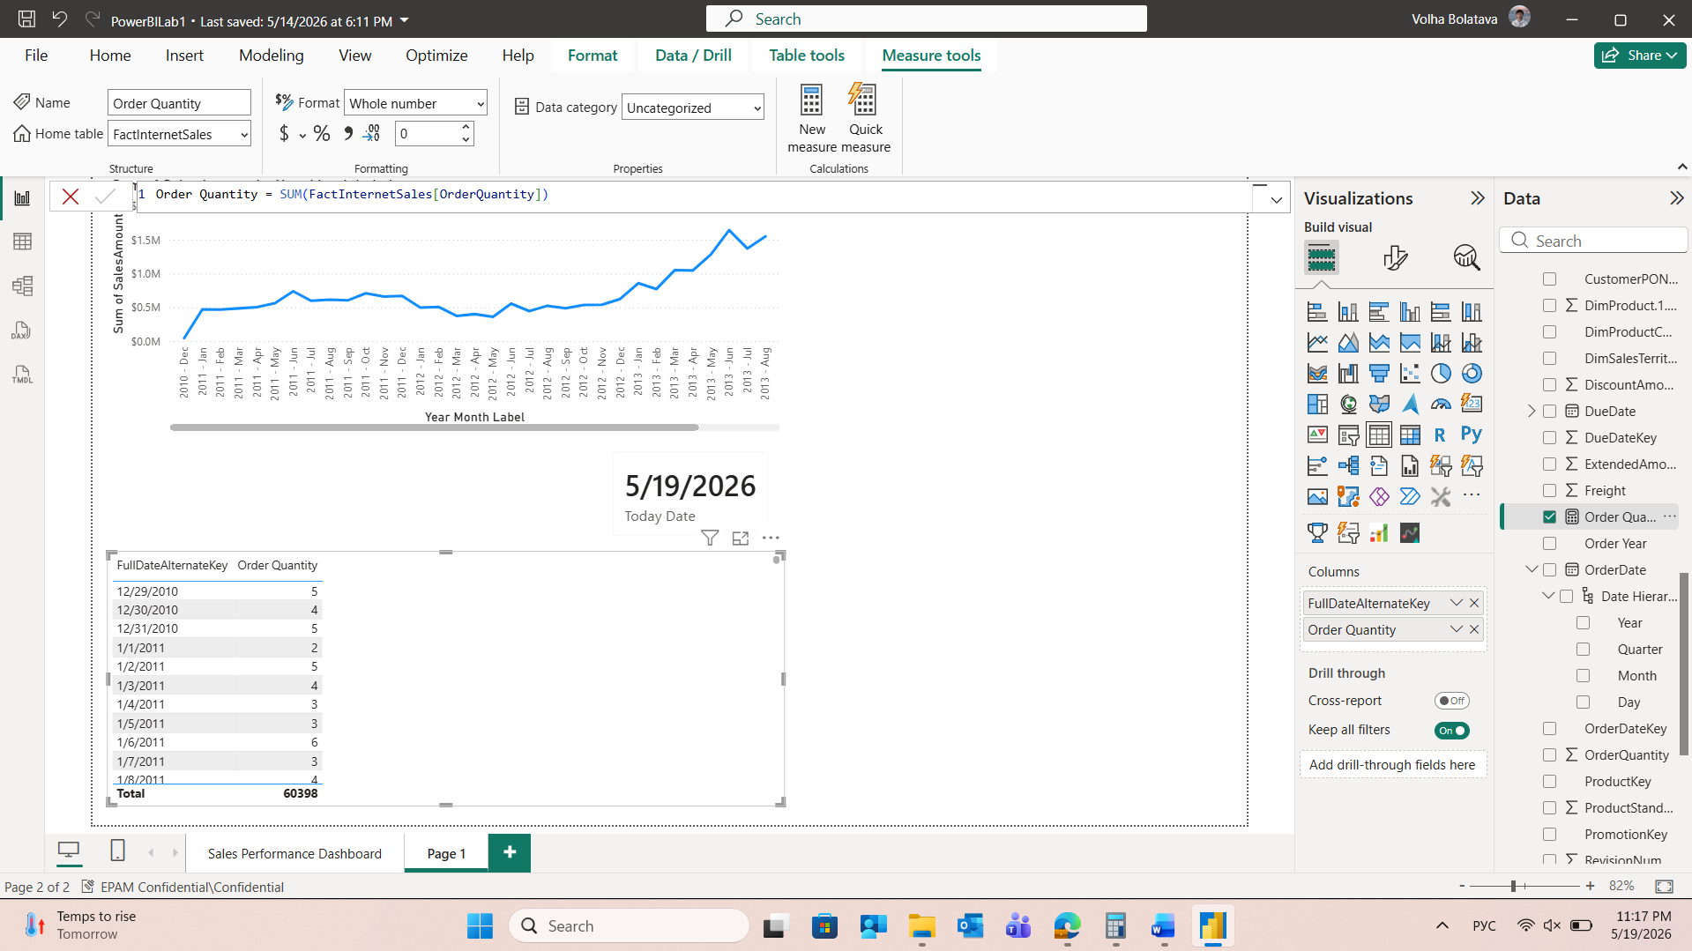
A simple table visualization with a date column and a newly created measure Order Quantity was added to the report. FullDateAlternateKey was presented in hierarchical way. So, the active date field was switched from Date Hierarchy to the plain column name FullDateAlternateKey. This disabled the expanded, multi-tiered tree format:
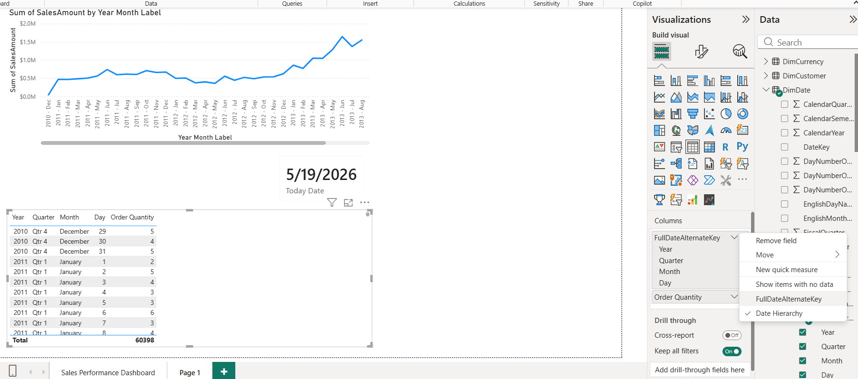
Also, in the data model, the column was selected and its format configuration on the top ribbon was changed to Short Date (M/D/YYYY). This removed the granular breakdown rows and consolidated the data into a clean, sequential chronological table.
Table visualization displays the [Order Quantity] measure grouped by date (FullDateAlternateKey). For each day, the measure calculates the total number of ordered units. The Total row at the bottom shows 60,398 — the grand total of all ordered units across the entire FactInternetSales table, confirming that the measure is aggregating correctly.
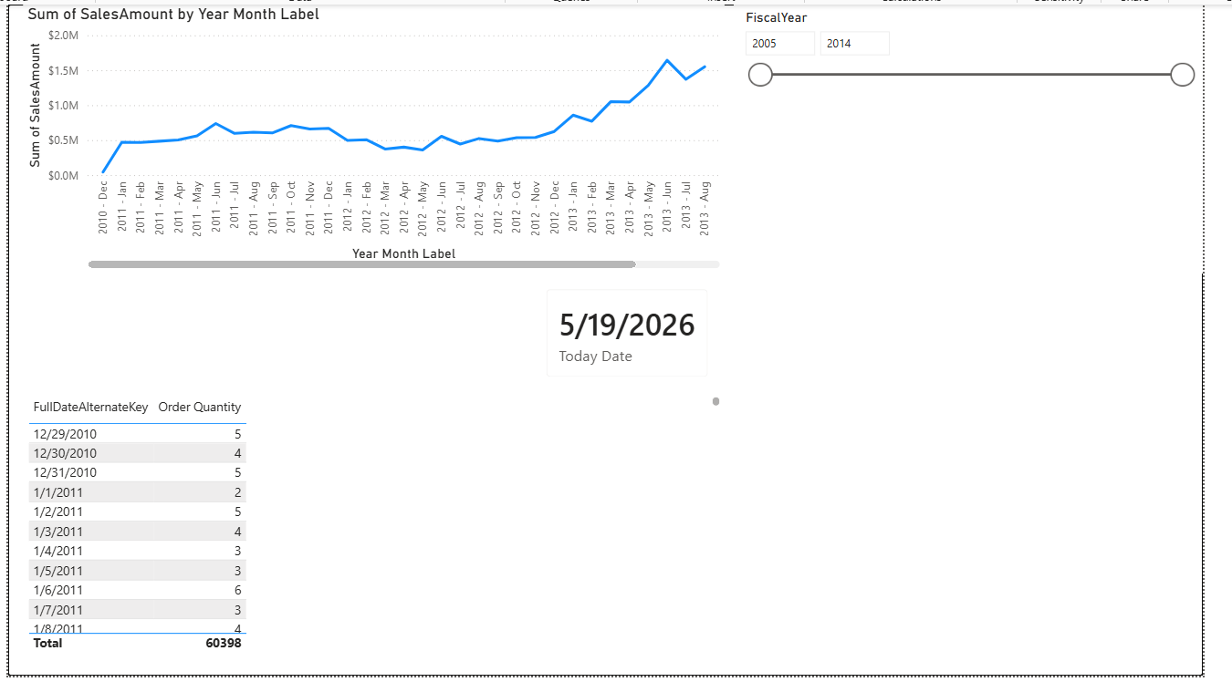
A new Year-to-Date (YTD) measure was created to calculate the cumulative order quantity. By combining the CALCULATE and DATESYTD functions, the formula creates a dynamic filter that captures all dates from January 1st up to the current date in the row context. This allows the system to evaluate the standard [Order Quantity] measure as a continuous running total.
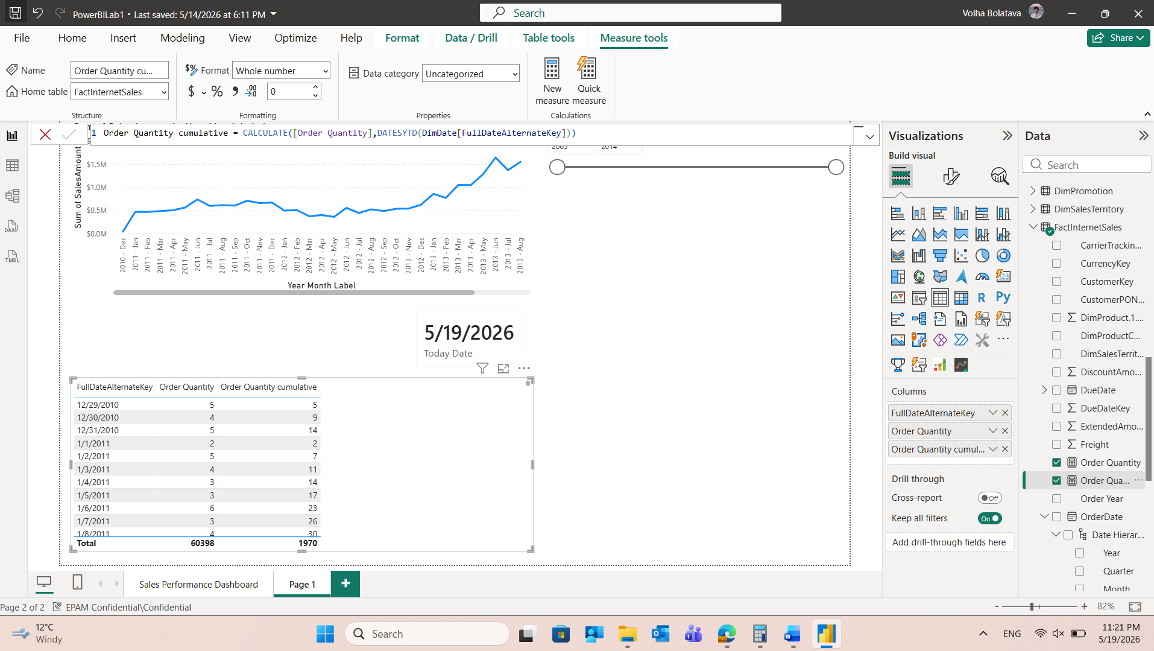
Once added to the table visualization, this measure provides a direct side-by-side comparison:
- Order Quantity: The absolute volume for that specific period.
- Order Quantity YTD: The cumulative total from the start of the current calendar year.
The YTD column accurately accumulates values month by month, automatically resetting to zero at the start of each new fiscal year, ensuring correct data tracking across the entire timeline.
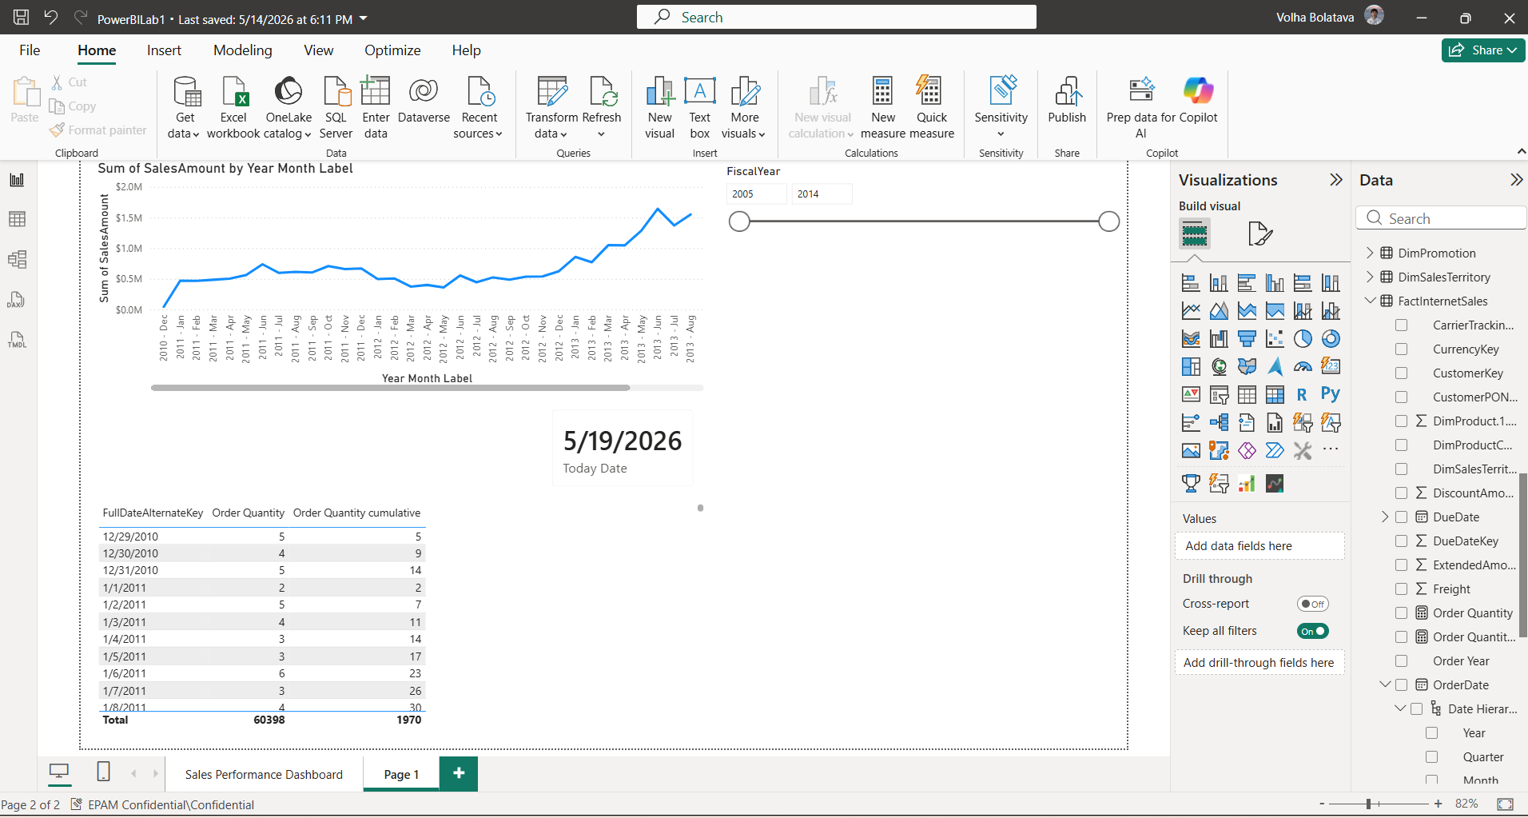

Create lab report
- To perform a year-over-year comparison of cumulative order quantities, two DAX measures were created and placed on a single Line Chart.
Current Year YTD Measure was created previously in LAB tasks - Order Quantity YTD and was renamed to OrderQtyYTD. It calculates the running total of orders from the start of the year up to the selected date. The second measure, OrderQtyYTD_PreviousYear, reuses the first measure inside CALCULATE with SAMEPERIODLASTYEAR, which shifts the date context back by one year so both lines can be compared on the same chart:
Measures were added to one Line Chart visual, so now the visual tracks both transactional volume metrics across a multi-year horizon:
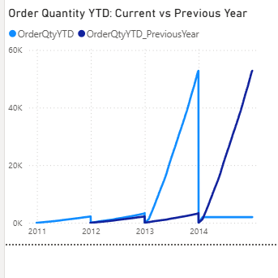
Light blue line (OrderQtyYTD) shows the cumulative order quantity from January 1st up to the current date in context. The value resets to zero at the start of each new year and grows continuously throughout the year.
Dark blue line (OrderQtyYTD_PreviousYear) shows the same cumulative calculation but shifted exactly one year back using SAMEPERIODLASTYEAR. For example, at the point of March 2014 it displays the YTD value as of March 2013.
- To support revenue tracking alongside order volume, the same year-over-year comparison was replicated for Sales Amount. First, a base measure Total Sales was createdЖ
Two additional DAX measures were then created — SalesAmountYTD using TOTALYTD and SalesAmountYTD_PreviousYear using CALCULATE with SAMEPERIODLASTYEAR — and placed on a second Line Chart visual using the same configuration:
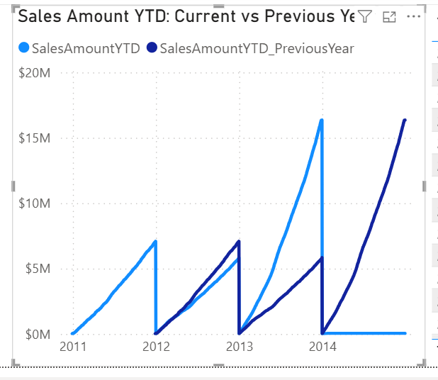
The light blue line (SalesAmountYTD) shows the cumulative revenue from the start of the year, resetting each January. The dark blue line (SalesAmountYTD_PreviousYear) shows the same cumulative total shifted one year back, allowing direct comparison of revenue growth at any point across the timeline.
- Two DAX measures were created to display a personalized greeting and the current date at the top of the report page, both added as Card visuals:
WelcomeMessage measure greets the user. USERPRINCIPALNAME() returns the email address of the currently logged-in Power BI user, allowing the report to display a personalized welcome message that changes depending on who is viewing it.
CurrentDateMessage shows the current date. FORMAT() converts the numeric date value returned by TODAY() into a readable text string using the specified pattern — in this case MM/DD/YYYY.
Both measures were added to the report as Card visuals placed at the top of the page, so every user sees their own name and the current date upon opening the report:

- A table visual was added to the report displaying Year-Month Label, Product Name, Color, Order Quantity, and a Percent measure showing each product's share of total order quantity within its group:
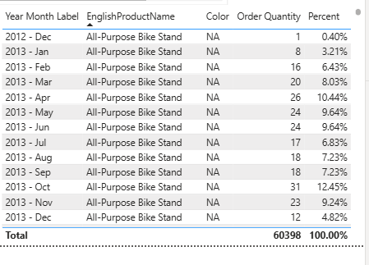
To show the percentage the percent measure was created. For each row in the table it divides the current row's order quantity by the total order quantity of the entire product group, returning each month's share as a percentage. The main logic was implemented using ALLEXCEPT(). It takes two types of arguments:
- First argument FactInternetSales — the table from which filters will be removed
- Second argument DimProduct[EnglishProductName] — the column whose filter must be preserved
So, it removes all filters from FactInternetSales — including Year-Month and Color (when ALLEXCEPT removes filters from FactInternetSales, it removes not just the direct filters on that table but also all filters that arrived through relationships — including the ones coming from DimDate (Year-Month) and DimProduct (Color)) — except the filter on product name. This means the denominator always sums up all orders for the current product across all months and colors, regardless of what else is selected in the visual.
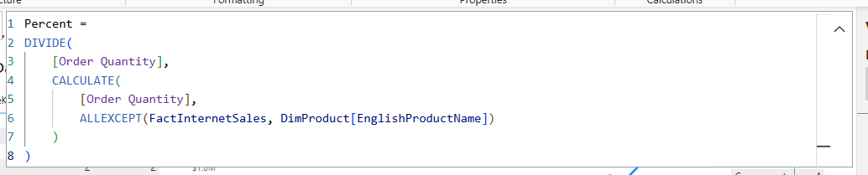
By keeping only the product name filter in the denominator, the percentages within each product always sum to 100%, making it easy to see which months were strongest for each individual product.
5. A DAX measure was created to always display the Sales Amount for the most recent date available in the data, regardless of any filters or slicers applied on the report page. The measure was placed in a Card visual, which is visible in the top section of the report showing $2.64K.
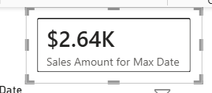
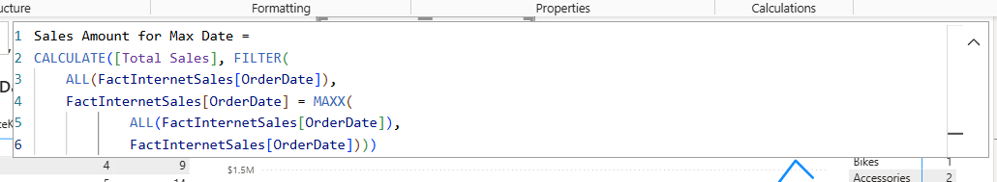
The measure works following:
- ALL(FactInternetSales[OrderDate]) removes any date filters currently active in the report and returns the complete list of all dates from the OrderDate column — ensuring the maximum date is always searched across the entire dataset, not just the filtered subset.
- MAXX(ALL(FactInternetSales[OrderDate]), FactInternetSales[OrderDate]) iterates over that complete unfiltered list of dates and returns the single highest date value — the absolute maximum OrderDate in the entire table.
- FILTER(ALL(...), OrderDate = MAXX(...)) then filters the date list down to only the rows where OrderDate equals that maximum date, producing a one-row filter table.
- CALCULATE([Total Sales], ...) evaluates the Total Sales measure within that filtered context — meaning it sums SalesAmount only for transactions that occurred on the maximum date.
The measure always returns a single value — sales for one specific date. A Card is the most appropriate visual for displaying a single KPI clearly and immediately. Using a line or bar chart would produce no analytical value since the measure returns the same number regardless of what period is shown on the axis.
6. A DAX measure was created to always display the country with the highest total sales across all years, regardless of any filters applied on the report page. The measure was placed in a Card visual.
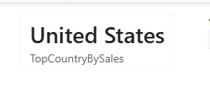
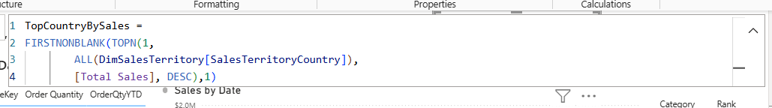
The measure works following:
- ALL(DimSalesTerritory[SalesTerritoryCountry]) removes any active filters from the territory dimension and returns the complete list of all countries — ensuring the ranking is always calculated across the entire dataset.
- TOPN(1, ALL(DimSalesTerritory[SalesTerritoryCountry]), [Total Sales], DESC) works in three stages:
Stage 1 — ALL(...) removes all active filters from the SalesTerritoryCountry column and returns a full list of every country in the dimension table. This ensures the ranking is never affected by slicers or page-level filters, so the top country is always evaluated against the complete dataset.
Stage 2 — Ranking For each country in that list, the engine evaluates [Total Sales] in the context of that country — meaning it calculates the total revenue attributed to each country individually. It then sorts all countries by that value in descending order, so the country with the highest sales moves to the top of the list.
Stage 3 — TOPN(1, ...) cuts the ranked list and returns only the first row — the country sitting at the top after sorting by Total Sales descending. The result is not a single value but a one-row table containing just that country name.
- FIRSTNONBLANK(..., 1) extracts the actual country name text value from that one-row table so the result can be displayed as a text label in the Card visual. Without this wrapper, CALCULATE would not be able to return a scalar text value directly from a table.
The measure always returns a single text value — the name of one country. A Card is the most appropriate visual for this since it communicates a single answer clearly and immediately.
7. A DAX measure was created to rank each product category by its Total Sales in descending order. The measure was added to a Table visual alongside EnglishProductCategoryName and Total Sales columns.
The measure Rank works following:
- ISINSCOPE(DimProductCategory[EnglishProductCategoryName]) checks whether the current row in the visual is showing an individual category value. This is necessary because tables in Power BI can have subtotals or totals rows — for those rows the category column is not in scope, so the measure returns BLANK() instead of trying to rank a total, which would produce a meaningless result.
- NOT(ISBLANK([Total Sales])) was added as a second condition using the && operator — if a category has no sales(like Components) data at all the rank returns BLANK() as well, keeping the table clean and preventing empty rows from receiving a rank number.
- ALL(DimProductCategory[EnglishProductCategoryName]) removes any filters from the category column so that every category participates in the ranking regardless of what is filtered elsewhere on the page. Without this, each category would only be ranked against itself and every row would return rank 1.
- RANKX(..., [Total Sales], , DESC, Dense) iterates over the full unfiltered list of categories, evaluates Total Sales for each one, and assigns a rank in descending order — so the category with the highest sales gets rank 1. The empty third argument means the current context value of Total Sales is used automatically. Dense ranking means if two categories have equal sales they share the same rank and the next rank is not skipped.
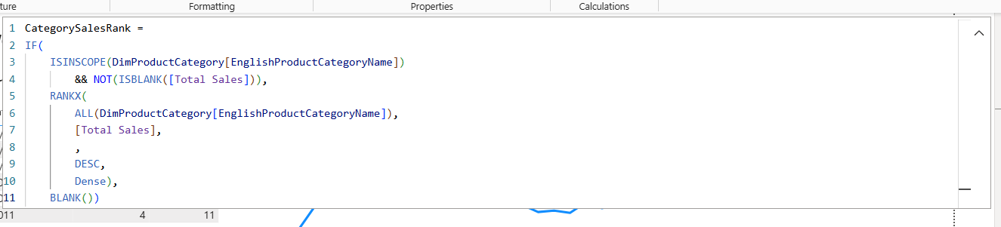
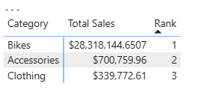
Ranking is inherently a comparative metric that only makes sense when multiple values are visible together. A Table allows the reader to see all categories, their Total Sales, and their corresponding rank side by side, making it immediately clear which category leads and by how much. A Card would only show one rank in isolation, and a bar chart would show sales volume but not the explicit rank number.
The final report the for LAB:
